- Modelling using the KAOS
Describes the modelling here (What is modelled). The choices of representation. Show the result of modelling with a figure.
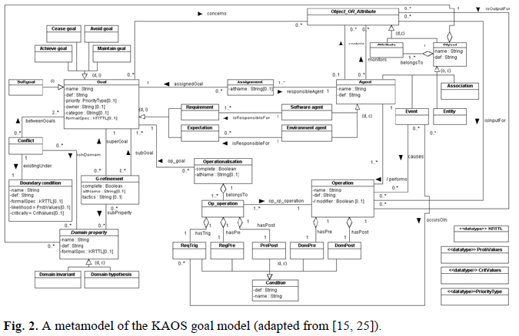

  - Observations
Give the description of the difficulties in modelling and explicit the need to extends KAOS.

